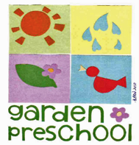

Garden Gazette

November/December 2018
Upcoming Events:
October 31: Halloween Party and trick or treating at Villa Santa Barbara ( Thank you to Diana Lund for hosting the party!)
November 12: Veterans Day, No School
November 20: Thanksgiving Party (Thank you to Laura Nelson for hosting the party!)
November 21-23: Thanksgiving Break
December 14: Parent’s Night Out Fundraiser, 5:30-8:30 pm
December 21: Christmas Party (Thank you to Ingrid Harris and Gabriella Moran for hosting the party!)
December 24- January 4: Winter Break

Why do we cook at school?

This past week, we made tortillas in the pre-k classroom!

Why do we do cooking projects at our school? Cooking projects are an excellent way for us to include basic skills for your preschooler, in a fun, and interesting way. For example, we can practice basic math skills when we measure ingredients such as 1 cup of flour, or 1/2 cup of water. We can practice scientific concepts such as making predictions! For instance, we may ask questions like “How do you think the dough will change if we add more water and why?” We use cooking projects to introduce new vocabulary such as masa, absorb, circular, knead ,and tortilla press. Cooking is a way to introduce the children to different cultures, inspire them to make healthy eating choices, learn vital social skills by working together to create the end product, teach them kitchen and general health skills, plus provide them with a hands on way to learn curriculum!

THIS MONTH’S
Article of the Month

Why we should let our children fail.
by Jessica Lahey on September 5th, 2015
When she realised her risk-averse parenting was holding back her children’s progress, Jessica Lahey took a step back and gave her boys the freedom to make their own mistakes.
I became a parent and a secondary school teacher in the same year. During my first decade raising two boys and teaching hundreds of children, I began to feel a creeping sense of unease, a suspicion that something was rotten. But it was only when my elder child started secondary school that my worlds collided and the source of the problem became clear to me: today’s overprotective, failure-avoiding parenting has undermined the competence, independence and academic potential of an entire generation.
Over a decade of teaching, I’d seen my students descend in to a constant state of fear and trepidation, a state that spells disaster for learning. When students are too afraid to take intellectual risks, too hesitant to raise their hand and take a chance on an idea that could change the course of class discussion, teachers can’t teach. It’s that simple.
We’ve ended up teaching our kids to fear failure – and, in doing so, we have blocked the surest path to their success. Out of love and a desire to protect our children’s self-esteem, we have bulldozed every uncomfortable bump and obstacle out of their way, depriving our children of the most important lesson of childhood: that setbacks, mistakes and failures are the very experiences that will teach them how to be resourceful, persistent, innovative and resilient.
I didn’t intend to teach my children to be helpless. On the contrary, I thought my kids would grow up brave, in the sort of wild, free idyll I experienced as a child. I wanted them to explore the woods with a pocket knife and a couple of cookies shoved in their pockets, build tree houses, shoot handmade arrows at imaginary enemies. I wanted them to have the time and the courage to try new things, explore their boundaries and climb one branch beyond their comfort zones.
Continue reading at: https://www.theguardian.com/lifeandstyle/2015/sep/05/parenting-tomorrow-why-should-let-children-fail

Featured staff member:
Devon Robles
Devon Robles has been a teacher here at Garden Preschool since January 2018, starting first as the afternoon teacher in the preschool room, and then transitioned to an all day teacher in the pre-k room at the beginning of the summer. Now, we want to welcome Devon as she transitions into a new role at Garden Preschool as the Assistant Director. With this new position, she will be working closely with Heidi to continue to strive to make Garden Preschool the best environment for your children. Devon brings with her 7 years of preschool teaching experience at various age levels ranging from infant to element school students. She earned her Bachelor of Arts in Early Childhood Studies from CSU Channel Islands, and her Masters of Education from Concordia University Portland. In her free time, Devon enjoys cooking, traveling, hiking and hitting the beach! She is also the mother to an almost 7 year old first grader! Lastly, Devon believes in a play based curriculum, she believes in an emergent curriculum based upon the interests of the children, and she is very interested in The Outdoor Classroom Project, which emphasizes nature and the outdoors incorporated into the curriculum.

Easy recipe to try! : Frozen Yogurt Fruit Bark
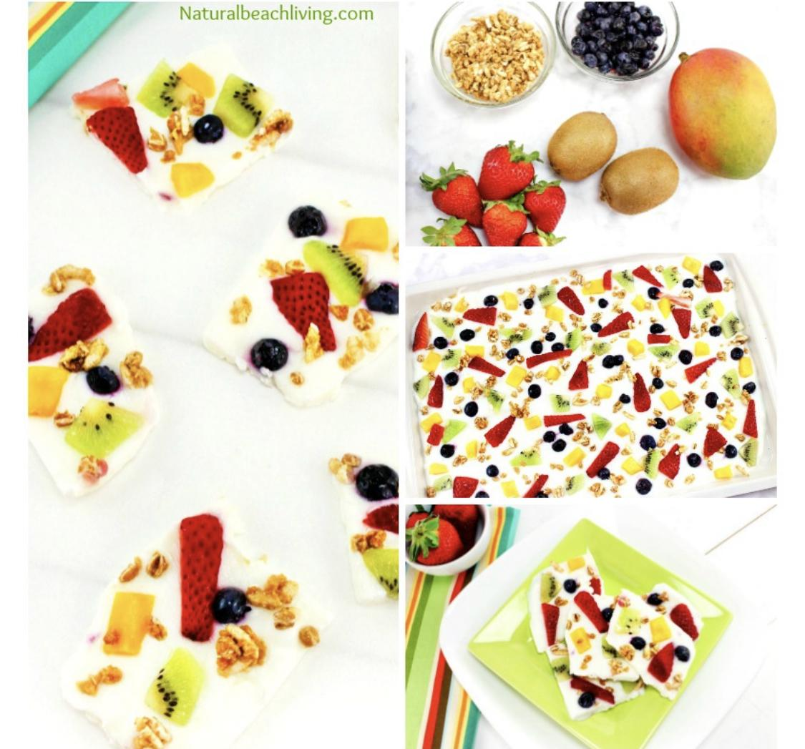
Ingredients
16-20 oz. plain or vanilla yogurt
2 Kiwi
4 Strawberries
1/3 cup Blueberries
1/3 cup Mango
1/4 cup Granola
Directions
1. Chop all the fruit into small bite-sized pieces.
2. On a small cookie sheet covered with parchment paper, spread the yogurt all over in an even layer.
3. Place the chopped fruit all over the top and sprinkle granola on.
4. Freeze for 2-3 hours or until frozen.
5. Break or cut large pieces off and hand out to kids or adults for a delicious, healthy snack. Eat right away or place back in freezer until ready to eat.
Recipe courtesy naturalbeachliving.com

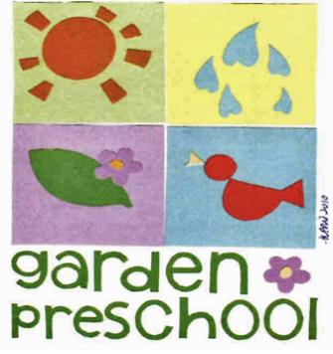
305 E. Anapamu
Santa Barbara, CA

